Programming Task

Git Repo Link: https://github.com/WaseemEng/su21-lab-starter/tree/main/lab04

This is factorial code in c for this I had write the risc v assembly code :

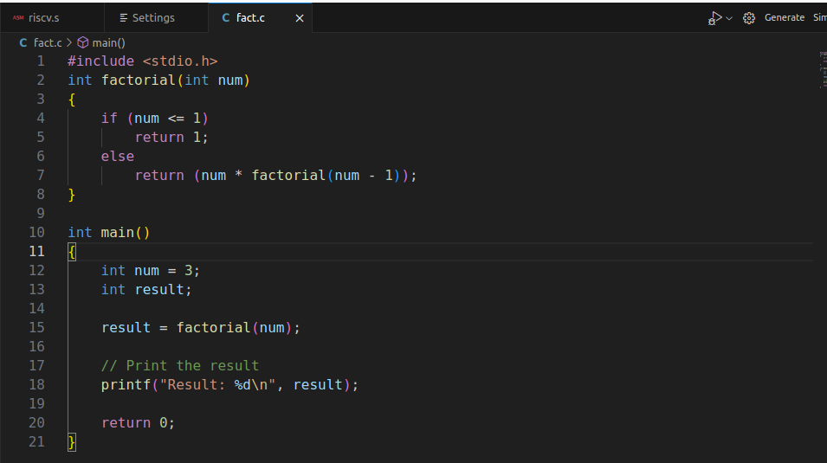
.globl main

.text
main:
la a1,number
lw a1,0(a1)
#calling a function
jal fact_with_rec

# storing return value in t2
la a3,result
lw t2,0(a3)
addi t2,a0,0
sw t2,0(a3)

j write_tohost # jump to write_tohost

#printing an integer result
addi a1,t2,0
addi a0,x0,1
ecall
#exit code
addi a0,x0,10
ecall

##### function with recursion #######
fact_with_rec:

#prologue
addi sp,sp,-8
sw a1,0(sp)
sw ra,4(sp)

addi a0,x0,1
addi t0,x0,1
beq a1,t0,done

addi a1,a1,-1 #num-1
jal fact_with_rec #factorial(num-1)

lw ra,4(sp)
lw t1,0(sp)
mul a0,a0,t1 #num*factorial(num-1)

addi sp,sp,8

jr ra
# jump to calling
done: addi a2,x0,1
jr ra

write_tohost:
li x1, 1
sw x1, tohost, t5
j write_tohost

.data
number: .word 4
result: .word 0

.align 12
.section ".tohost","aw",@progbits;
.align 4; .global tohost; tohost: .dword 0;
.align 4; .global fromhost; fromhost: .dword 0;

Terminal Output:
when I run the code to see the de assembly:
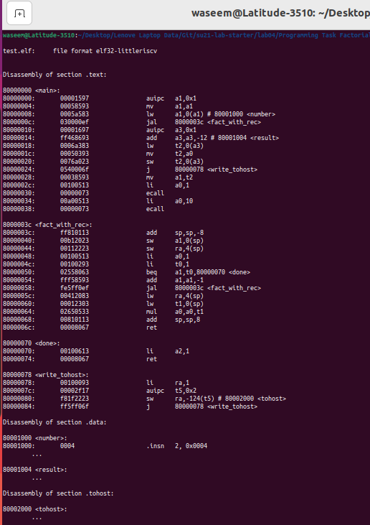
Log file:
factorial of 4 Is 24 which is 0x18 in hex and this shwon in the above and result store in s0 register.
Result is shown at address 0x80001004 and result is 0x18 which is factorial of 4.
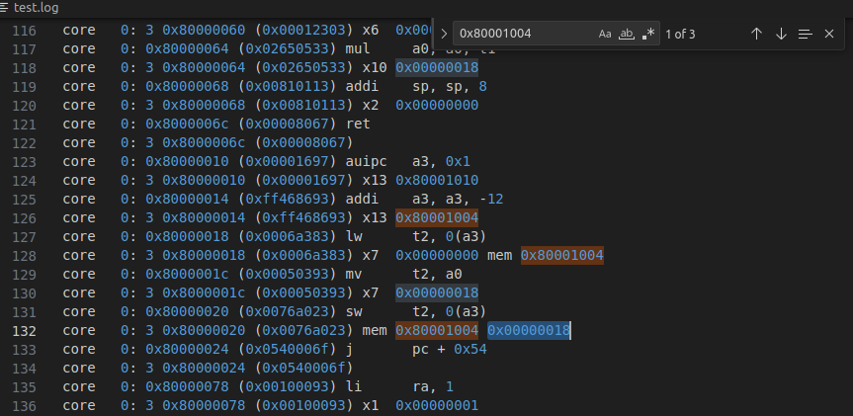

Linker file code:
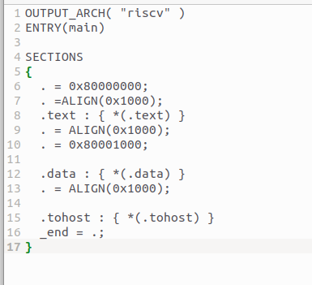

Block Diagram :
